DOLLY'S CLUB

Website specifications
The purpose of my website is to support students emotionally and socially through advice, tips and resources. It informs users about the club, activities and events taking place in the club.
It’s goals to business:
- It provides information to customer and helps them understand what the business offers without them visiting personally.
- Improve communication as its aim is to give tips and advice to young adults.
- Supports growth of the club as it attracts a lot of members.

Target audience and it’s demographics:
The target audience of my website are teenagers to young adults.
Demographics:
- Age group; young adults of age range 13-25 years
- Gender; It is open to all gender
- Educational level; Mostly students attending secondary school, college and tertiary.
- Technical ability; people using smart phones, laptops and computers.
- Interests; social activities, club events, entertainment and are interested in making new friends.

Technical aptitude

- Skill level; beginners to basic users not experts in technology
- Device used; mostly smartphones and laptops
- Internet usage; they should know how to open a website link and view information.

EXPECTATIONS
- The site should be easy for users to use with simple layout and clear menu.
- Users expect a fast-loading app where pages open quickly, and images does not slow down the site
- It should be mobile friendly meaning it should work well on phones, images and text must fit the screen
- It should have an attractive design, that is a clean and neat appearance with nice colours. The content should also not be crowded and that is for readability.

TYPE OF WEBSITE AND CONTENT

- This is informational club website which will provide details about the club, it is a simple and easy to use. It should inform and attract members. The content includes a home page with an introduction content an about page providing information about the club and explaining the clubs purpose, a membership page providing information about membership plans and also allows visitors to join and manage membership, an events page showing upcoming and past activities, support page that provides help to users by providing answers to common questions , gallery page showing photos and videos related to the club and its activities and contact page for communication. Lastly it should be simple and easy for users to understand.

INFORMATION DESIGN AND TAXONOMY

Site Map
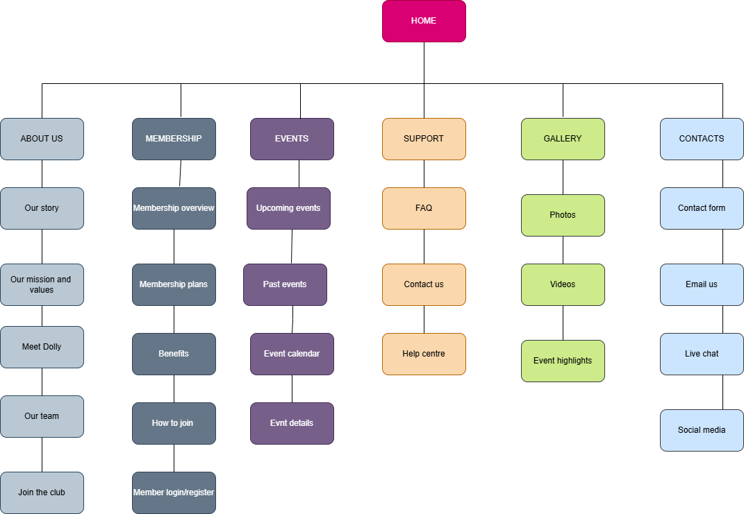

TECHNOLOGIES USED BY MY WEBSITE

- Hypertext markup language (HTML); used to create the structure of my website, it also organises my content such as the headings and the paragraphs.
- Cascading style sheet; It designs the appearance of my website, control colours, fonts and spacing. It also makes the website attractive and user friendly.
- Java scripts; It adds interactivity to my website also adding buttons and menus
- Design tools; Draw io used to plan my site maps. It also designs the structure and layout of my site before development. Figma used to structure and design my website.
- GitHub and GitHub pages; GitHub used to store and manage website files and GitHub pages help to host my website live

